

上海交通大学学位论文

海铃光电混合舱的物理信号研究

姓 名：魏振宇

**学 号：**519072910021

导 师：徐东莲

学 院：物理与天文学院（致远荣誉计划）

学科/专业名称：物理学

申请学位层次： 学士

20XX年XX月

A Dissertation Submitted to

Shanghai Jiao Tong University for Bachelor Degree

Probing Physics Potential with TRIDENT hDOM

Author: Zhenyu Wei

Supervisor: Donglian Xu

Zhiyuan College

Shanghai Jiao Tong University

Shanghai, P.R.China

June 28th, 2021

上海交通大学

学位论文原创性声明

本人郑重声明：所呈交的学位论文，是本人在导师的指导下，独立进行研究工作所取得的成果。除文中已经注明引用的内容外，本论文不包含任何其他个人或集体已经发表或撰写过的作品成果。对本文的研究做出重要贡献的个人和集体，均已在文中以明确方式标明。本人完全知晓本声明的法律后果由本人承担。

学位论文作者签名：

日期： 年 月 日

上海交通大学

学位论文使用授权书

本人同意学校保留并向国家有关部门或机构送交论文的复印件和电子版，允许论文被查阅和借阅。

本学位论文属于 **：**

□公开论文

□**内部论文**，保密□1年/□2年/□3年，过保密期后适用本授权书。

□**秘密论文**，保密 年（不超过10年），过保密期后适用本授权书。

□**机密论文**，保密 年（不超过20年），过保密期后适用本授权书。

（请在以上方框内选择打“**√**”）

学位论文作者签名： 指导教师签名：

日期： 年 月 日 日期： 年 月 日

# 摘 要

学位论文是本科生从事科研工作的成果的主要表现，集中表明了作者在研究工作中获得的新的发明、理论或见解，也是科研领域中的重要文献资料和社会的宝贵财富。

为了提高本科生学位论文的质量，做到学位论文在内容和格式上的规范化与统一化，特制作本模板。

**关键词**：学位论文，论文格式，规范化，模板

# ABSTRACT

As a primary means of demonstrating research findings for undergraduate students, dissertation is a systematic and standardized record of the new inventions, theories or insights obtained by the author in the research work. It can not only function as an important reference when students pursue further studies, but also contribute to scientific research and social development.

This template is therefore made to improve the quality of undergraduates’ dissertation and to further standardize it both in content and in format.

**Key words:** dissertation, dissertation format, standardization, template

**CONTENTS**

摘 要 I

ABSTRACT II

Chapter One Introduction 1

1.1 Neutrino 1

1.2 Neutrino Astronomy 2

1.2 Neutrino Telescope Overview 3

1.2.1 DOM 3

1.2.2 Neutrino telescopes around the world 5

1.2.3 Detection Principles 8

1.2.4 Signal and Background for TRIDENT 11

1.2.5 Trigger Overview 13

1.3 Purpose of Study 18

Chapter Two Trigger Strategy 19

2.1 Trigger Strategy Design 19

2.2 hDOM internal Trigger 20

2.3 Physics Filter 22

Chapter Three Performance of Trigger 25

3.1 Simulation Framework 25

3.1.1 Analysis method 28

3.2 Background Reduction 28

3.2.1Dark Noise 28

3.2.2 K-40 29

3.3 Signal Event Evaluation 30

3.3 Summary 31

Chapter Four Future Improvements and Outlook 32

4.1 Physics Filter Optimization 32

4.2 Data Acquisition System 32

References 33

Symbols and Marks Appendix 1 34

Research Projects and Publications during Undergraduate Period 35

Acknowledgements 36

# Chapter One Introduction

## 1.1 Neutrino

Neutrino is firstly proposed by Wolfgang Pauli in 1930 to fix the problem of energy and momentum non-conservation effect in beta decay. In 1942, Ganchang Wang proposed the use of beta capture from 7Be to experimentally detect neutrinos. In 1956, the tiny particle is directly detected for the first time in Cowan-Reines neutrino experiment. In the experiment, antineutrinos created in a nuclear reactor are captured by protons in 200 liters of water, and a pair of neutron and positron is produced, generating a time corelated signals. The neutron is captured by 40 kg of dissolved CdCl2 in water and the positron is annihilated by electron. This great breakthrough won 1995 Nobel prize. This beautiful experiment is the prelude of all kinds of neutrino detections latter on.

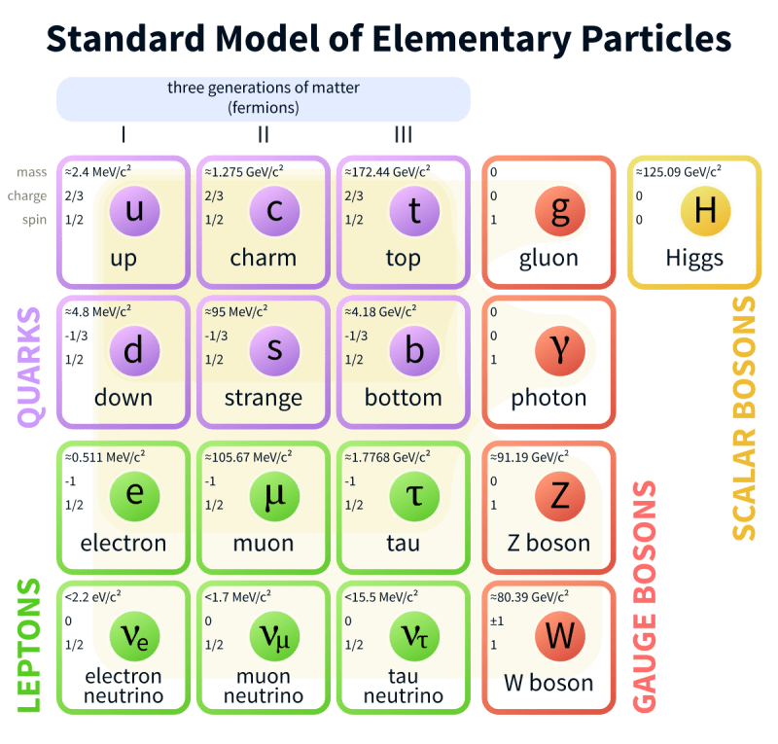

Figure Standard Model. Neutrino is a kind of elementary lepton. Source: wiki

This is a kind of charge-neutral lepton with spin 1/2, which is categorized in three different flavors: electron neutrino 𝜈𝑒, muon neutrino 𝜈𝜇, tau neutrino 𝜈𝜏. Since the mass eigenstates and the flavor eigenstates of neutrino do not overlap, the probability of observing a certain flavor neutrino varies as it propagates(Flavor Oscillation Effect, 2015 Nobel Prize).

Until this day, many science problems around neutrino still wait for us to answer. Whether neutrino is a kind of Majorana fermion is still elusive in science frontier up to now. If neutrino is Majorana fermion, then the law of lepton conservation may be broken. New physics that is beyond standard model is hidden behind. In experiment, observing neutrinoless double beta decay ($0νββ$) from N(A,Z+2) element decay is the key to uncover the mystery.

## 1.2 Neutrino Astronomy

Neutrino only involves in weak interaction and gravity interaction. Its small cross section induces very scarce reaction events. So neutrinos are sometimes referred as ‘ghost’ particles since they penetrate most substances easily. This kind of nearly massless elementary particle is generated mainly in hadronic process or nuclear reaction(beta+/- decay and election capture), which is enriched in the nuclear power plant, celestial bodies, and earth atmosphere as the high-energy cosmic ray Bombarding atmospheric atoms. The flavor, direction, and energy spectrum of neutrinos are widely different as the sources varies. Generally, high-energy neutrino generation marks occurrence of violent hadronic processes. The processes can be summarized as

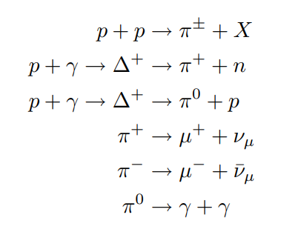

Compared to GeV and above high-energy photons which is deflected by pair-productions, neutrino travel longer with less absorption or deflection in interstellar space. In universe observation, these oscillating high-energy particles can be utilized as a powerful tool to study the astronomical sources since neutrinos’ flavor constituents, direction, and energy of neutrino jets carry very rich physics information. Neutrino sources is widely considered as a smoking gun evidence for ultrahigh energy cosmic ray production, which is a centennial problem for human-being. In 2013, IceCube discovered a diffuse astrophysical neutrino with several potential sources included, such as active galactic nuclei, gamma-ray bursts, and starburst galaxies. In 2017, IceCube linked observed high-energy neutrino with flaring blazar TXS 0506+056 with a 3.5 sigma confidence interval, which indicates an upcoming groundbreaking in multi-messenger astronomy.

IceCube also carries out systematic search for neutrino sources of different categories. Gamma Ray Burst(GRB) , Active Galactic Nuclei(AGN) and Blazars, Galactic Neutrino Source, Fast Radio Burst(FRB), Compact Binary Coalesces(CBC) as well as Tidal Disruption Event(TDEs) are all considered, while all final conclusions drawn from co-analysis up-to-now do not solve the puzzles completely. It seems that most of astrophysics neutrino jets may come from numerous weak sources, instead of dominant single source. High-energy neutrino source searching is still on the way.

## 1.2 Neutrino Telescope Overview

These tiny particles are observed using extremely sensitive technologies in large volume. The secondary charged particles generated in neutrino-matter interactions induce detectable Cherenkov optical photons. A large body of target optical medium, such as sea water or Antarctic ice are continuously monitor by photon-sensors. This is namely the idea of building the massive Cherenkov Optical Neutrino Telescope to detect high-energy celestial neutrinos. In 1960, M. Markov published this breakthrough idea. At the current level of human productivity, this is the only method to accumulate enough statistics.

### 1.2.1 DOM

Digital Optical Module, namely DOM, is the cell of the neutrino telescope. Deploying DOM arrays to detect Cherenkov optical photons is main body of neutrino telescope construction. Normally, (take DOM in IceCube as an example here) DOM is capsuled by a special glass sphere shell. The term ‘special’ here points to high pressure resistant (250bar for example, corresponds to 2.6km depth in seawater), high transparency in optical waveband, and low radioactivity to avoid extra background. A PMT or multiple PMTs are deployed in the shell.

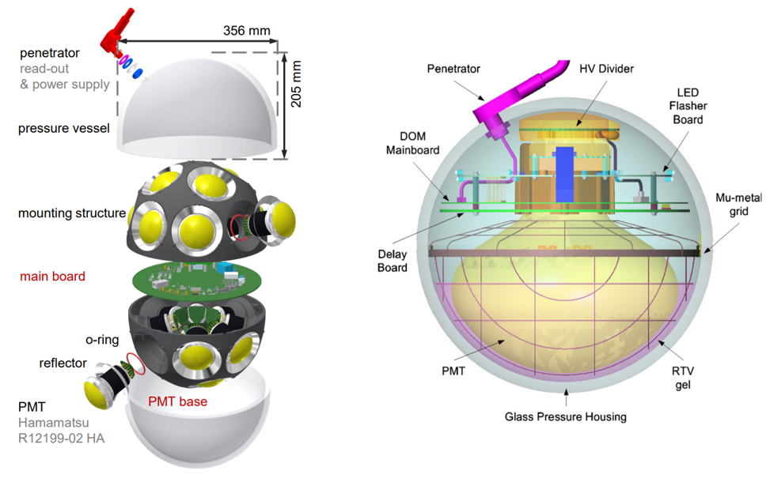

Figure 2 Left Panel: KM3NeT mDOM (multi-digital optical module) internal design. Right Panel: IceCube DOM internal design. Optical gel (refractive index~1.4, very transparent) are added between PMT surface and the shell to reduce photon loss. Large PMT also requires a metal net covering to shield geomagnetic field.

PMT, namely photomultiplier tube, multiplies the current produced by incident light (photoelectric effect in photocathode) by as much as tens of million times in multiple dynode stages, finally creates digitizable macroscopic election current, which enabling single photon detection.

The main parameter of PMT is listed below:

1. Quantum Efficiency (QE): The probability that an incident photon in the photocathode can generate a electron. Normally, for 460nm, this number is around 30%.
2. Gain: Amplification factor that currents are gained after going through multiple dynodes.
3. Single photoelectron waveform: the waveform of a single photon. The key characteristic of the waveform are rising time, falling time and the peak amplitude.
4. Single photoelectron resolution: the peak-to-valley ratio between the single-photon peak and zero-photon peak in the charge distribution. This marks the ability of one PMT to distinguish single photon signals from baseline fluctuation.
5. Transient time spread: The full width at half maximum of transient time distribution. This quantity will in the end limit the angular resolution of the neutrino telescope.

Currents from the anode in the PMT will be digitized through electronics. Analogue Digital Convertor (ADC) or Time Digital Converter (TDC) will be implemented. This depends on certain circumstances. The former one can sample the waveform in a time interval. (For example, 500MHz ADC digitizes waveforms in 2ns time interval.) The latter one count the number of rising edge. Instead of the whole waveform, only the hit time and time-over-threshold or the amplitude will be transmitted.

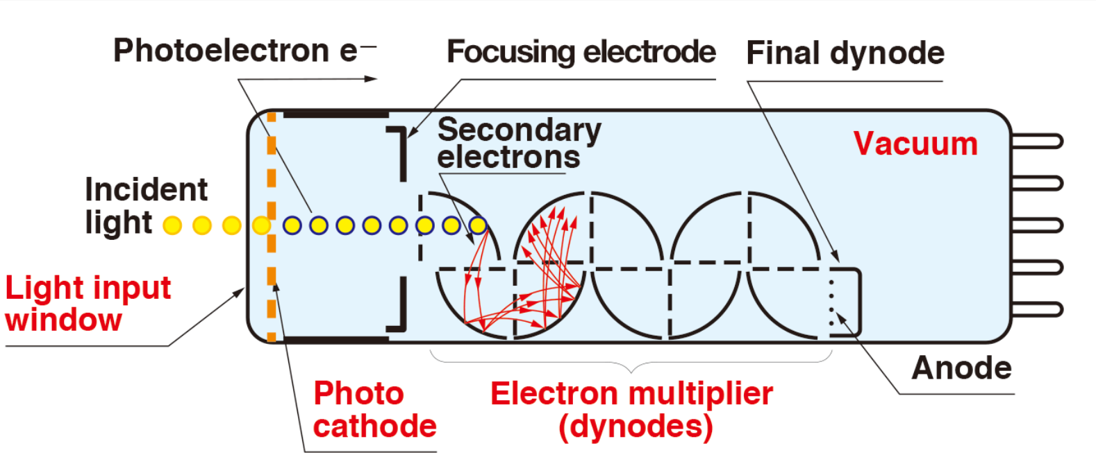

Figure 3PMT working principle. High voltage (~1kV) is applied in the vacuum tube. Currents from photocathode is multiplied level by level in several dynodes. Finally, they are collected in the anode.

### 1.2.2 Neutrino telescopes around the world

In 1998, theoretical calculations suggested that high-energy neutrino flux from AGN(Active Galactic Nuclei) jets or GRB(Gamma Ray Burst) can be observed by a cubic-kilometer detector with sufficiently sensitivity. Numerous interesting topics about cosmic neutrino, along with new physics beyond the Standard Model and quantum gravity, can be studied through the neutrino telescopes. Several neutrino telescopes around the world are under development now. Their geometry design, technical route, noise source and the monitoring sky region are widely different. In this paper, neutrino telescopes point to digital optical module(DOM) arrays. Askaryan effect are also another method to observe neutrinos. These kind of neutrino telescopes such as GRAND are not involved in here.

1. IceCube

IceCube, located in the deep Antarctic ice, is the largest running Cherenkov neutrino telescope in the world. In the surface, IceTop possesses 81 stations and 324 optical sensors. Below the ice surface, 5160 Digital Optical Modules in total are deployed uniformly in 86 strings, monitoring one cubic kilometer volume. DeepCore, constituted by 8 strings with 480 DOMs, is designed for optimization of lower energies in IceCube experiment. Generally, DOMs form a uniform space lattice with translational symmetry mostly. The neighbor string distance is 125m and the vertical spacing of DOMs in string is 16.7m.

DOM in IceCube utilizes one 10-inch diameter PMT. The dark count, which is around 500Hz per DOM, is the main noise source on the DOM level. For a triggered(called hard local coincidence in IceCube) photon hit, the waveform will be read out in 300MHz sampling rate, while for un-triggered photon hit (isolated photons, called soft local coincidence in IceCube), only the time and amplitude will be read out. After event selections, 100GB/day data stream are transmitted to the north over satellite for further analysis.

1. KM3NeT

KM3NeT is a water-based neutrino telescope in the Mediterranean sea mainly driven by EU. Two clusters of strings form ARCA in Italy(Astroparticle Research with Cosmics in the Abyss). And one cluster constitutes ORCA (Oscillation Research with Cosmics in the Abyss) in French.

ARCA will possess instrumented volume of about 1 cubic kilometer with 230 strings comprised of 18 optical modules, slightly larger than that of the IceCube. ORCA will a total densely instrumented volume of about 0.0067 cubic kilometer. The construction of ARCA provides some valuable references for other water-based neutrino telescopes. They developed mDOM(multi-Digital Optical Module) with 31PMTs to detect neutrinos.

1. P-ONE

P-ONE(Pacific Ocean Neutrino Experiment) is located at a depth of 2660 meters in the Cascadia Basin. The geometry is designed in cluster shape. Each cluster has 10 strings equipped with 20 DOMs. The strings in one cluster form a double-ring structure, and the inner ring has radius 100m with 3 strings and the outer ring possesses 7 strings in the radius of 200m. The large detection array is composed of 7 clusters in total. The average distance between clusters is 1km. Their site is monitored by two pathfinder experiments named STRAW. The optical property of water and the environment parameters such as water velocity are evaluated. Their first prototype line is expected to be deployed in 2023.

1. Baikal-GVD

Baikal Gigaton Volume Detector(Baikal-GVD), with 192 modules successfully operated at a depth of 1.1km, is still under development. The start of Baikal-GVD can date back to 1980, when a laboratory of high-energy neutrino astrophysics was established in Moscow in USSR. They plan to finish the construction in multiple phases. NT-36, NT-72,NT-200 and NT-1000 is performed in sequence. They also implement the cluster-like shape design to adapt to the expenditure. The DOM used in Baikal-GVD only contains one large PMT, and the lake water does not contain any K-40, so its bandwidth is not that large. Since its depth is 1.1km, the rate of atmospheric muons is relatively large.

1. TRIDENT: the next generation neutrino telescope

The tRopIcal DEep-sea Neutrino Telescope, TRIDENT for short, will be deployed on the abyssal plane at South China Sea. Since abyssal water, compared to the glacial ice of IceCube, contains less impurity, Trident will have added advantage in reducing photon scattering. Neutrino pointing in both the track and cascade channels can be benefitted. Also, since the latitude is low, TRIDENT can conduct the whole sky survey with the rotation of the earth.

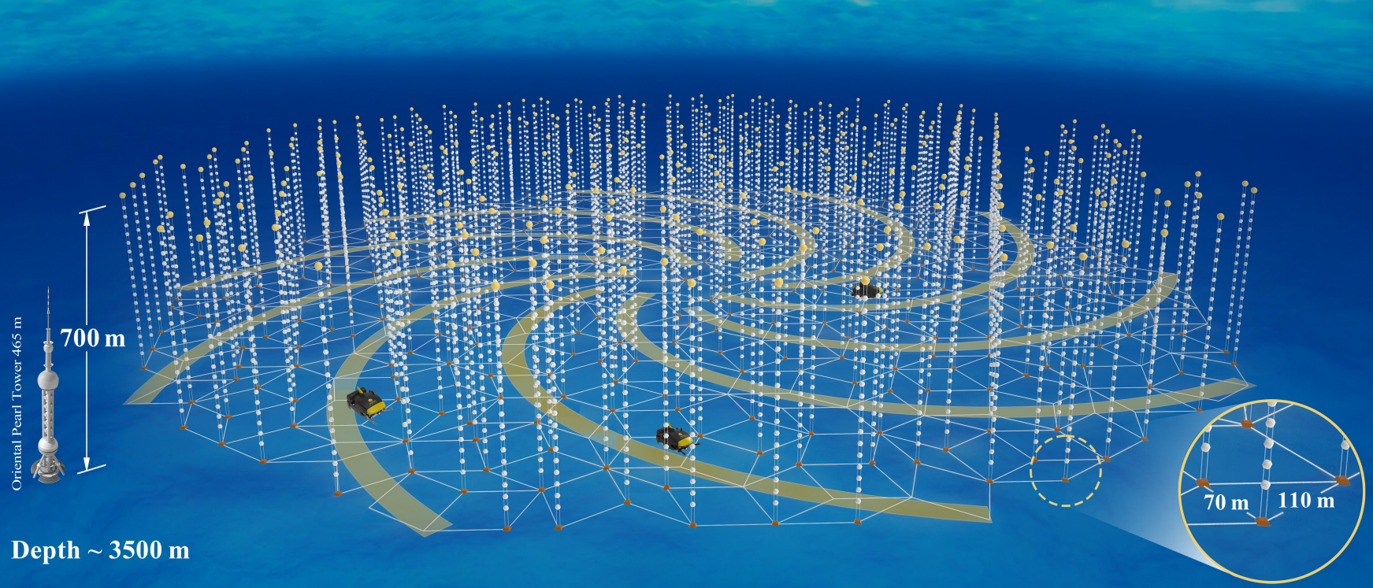

Figure Rendering Diagram of Trident

The telescope will have an Penrose geometry layout with 1211 strings and 22400 hybrid digital optical modules covering a volume of about 8 cubic-kilometer. Simulation shows that this kind of unsegmented geometry can reduce the clipping edge events(the events which happened in the edge of the detectors, more likely to occur in the clustering geometry). The spiral geometry can also deal with the ‘corridor events’(referred to the events which pass through parallel arrays of strings in the detector). We also consider the requirement of ocean engineering when deploying the strings. ROV(Remote Operated Vehicle) paths are left on the sea floor spirally. These ROV paths can help to conduct detector construction as well as long-term maintaining.

We also consider the layout of junction box system in the detector. Data transmission and power supply are implemented through junction box. Preliminarily, each sub-junction box point(triangle mark in the Figure 3) serves for adjacent 20 strings. The bandwidth and power consumption of strings will decide this number in future construction.

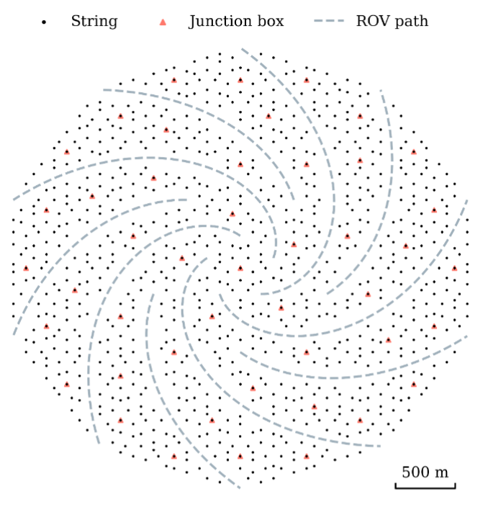

Figure The layout of Trident. Penrose tilt is implemented.

State-of-the art technologies will be included in hDOM(hybrid digital optical module) design. More than 30 3-inch PMTs and more than 20 1-inch PMTs or SiPMs will be integrated together to achieve high time resolution and excellent light collection ability. This next generation telescope carries more ability to pinpoint the astrophysical neutrino sources, as well as stays sensitive to all flavor neutrinos for multiple critical physics purposes.



Figure hDOM design picture. 31 PMTs and 24 SiPMs are set in the layout. The simulation project introduced in the later chapter also comply with the design here.

### 1.2.3 Detection Principles

When high-energy neutrinos pass through the medium, deep-inelastic scattering(DIS) may occur between the neutrinos and the nucleus in the medium through the weak interaction. The secondary particles that are charged and largely boosted can be generated through DIS.

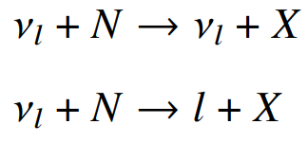

N is the nucleus, and l is the lepton. X is the hadronic cascade, full of pions and Kaons.

These high-energy secondary charged particles’ velocity is very close to the speed of light, say c, in vacuum, which the light speed in water, normally 0.75c, is significantly less than. Water is a common dielectric medium that can be polarized electrically. In the case, Cherenkov radiation effect can occur. Secondary charged sparticles carry the information from neutrino due to the conservation of energy and momentum, and emit a large amount of Cherenkov photons. The Cherenkov photons generated along the trajectory follow a fixed emission angle and can be captured by the DOMs in the neutrino telescope. This is the detection principle of neutrino telescopes. The well-known emission angle can be written as $cos(θ) = \frac{1}{nβ}$. This angle property is the foundation of direction reconstruction in neutrino telescope.

The arrival time of a un-scattered Cherenkov photon in the detector can be written as

$$t_{i}=t_{0} + \frac{z_{i}-z_{0}}{c}+tanθ\frac{r_{i}}{c}$$

All quantities are marked in Figure 1. This expressions are applied in the likelihood method in the reconstruction and also the muon event filter algorithm(This will be discussed in later chapter). All photons emitted from the same muon track should obey the law of causality, when scattering effect does not slow down the average velocity too much. This property can be utilized to limit the direction range of muons before reconstruction.

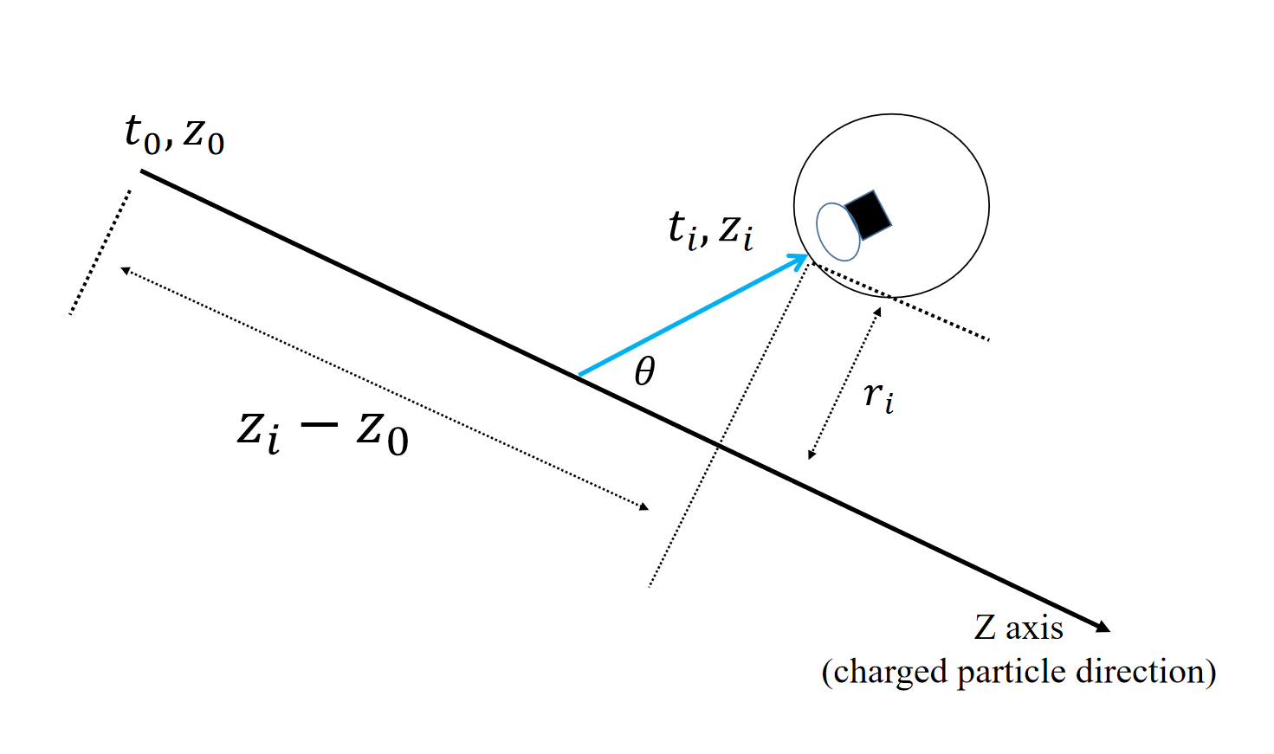

Figure Cherenkov photon arrival time. The blue curve is the track of an emitted Cherenkov photon. $θ$ is the Cherenkov angle.

As for the energy spectrum of Cherenkov photons, the description is given by the Frank-Tamm formula.

$$\frac{d^{2}E}{dxdω}=\frac{q^{2}}{4π}μ(ω)ω(1-\frac{1}{β^{2}n^{2}(ω)})$$

This equation involves $μ(ω)$, the permeability, $n(ω)$, the refractive index and $q$, the electric charge. It calculates the amount of energy emitted per travelling length and per frequency. Since the radiation energy is larger when $β$ factor is closer to 1, more photons can be accepted by DOM for higher energy events. Also, more charged secondary particles can be generated from higher energy events. More photons received generally, more energy the particle carries. This lays the foundation for the energy detection in the neutrino telescope. According to the formula, the energy spectrum of Cherenkov photon is quite flat in optical region. Considering strong absorption effect of water in both large and small wavelength region, only wavelength around 450nm(blue light, 2.76eV) can mostly go through the medium. Since water only opens a window for the light from 2 to 3 eV, our PMTs and SiPMs inside the DOM should be sensitive to this wavelength band.

When substituting all constants in the Frank-Tamm formula and assuming the minimum ionization process, only considering optical photon part, we can obtain a simplified equation for rough estimation. Basically, losing each 2MeV when traveling along the trajectory, 200 Cherenkov photons can be generated.

$$\frac{dN}{dE_{deposition}} \sim = 200photons/MeV$$

Intuitively speaking, the signature of muon neutrino events, electron neutrino events and tau neutrino events are distinguishable, since properties of secondary particles are different. Muons, as well as some of tauons, travels longest, electrons bombard out a shower, and tauons both generate a shower and decay. Largely boosted muon neutrinos is viewed as the golden channel to search the astrophysical source in multi-messenger astronomy since muon tracks are usually very long($O(1000m)$) and the reconstruction angular error is the smallest of all flavor. The angle between the induced muon and the neutrino can be approximated as the following expression:

$$∆θ(ν-μ)\sim \frac{1.5°}{\sqrt{E_{ν}[TeV]}}$$

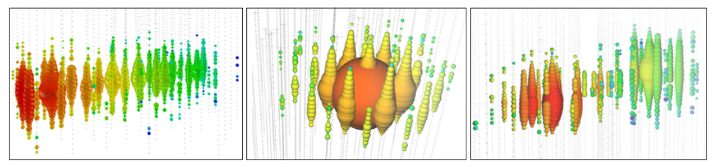

Figure Three examples of event signatures in IceCube. From left to write, a track-like event, a shower-like event, a simulated double-bang event are presented. They are considered as a muon event, electron event, and a tauon event. The DOMs are lightened by Cherenkov photons described above. The signature of events sometimes still degenerate.

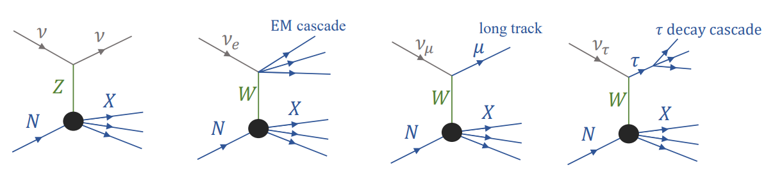

Figure Feymann Diagram of DIS. It corresponds to the event signatures mentioned above.

The degeneration of signatures can still occur, since tauons can be track-like or shower-like. Clipping edge events only shed light on a few DOMs on the boundary, so it is not that easy to identify. Classification of particles is also a critical process in data analysis, where both machine learning and classical likelihood methods can be involved in.

### 1.2.4 Signal and Background for TRIDENT

In this paper, we generally refer the ambient noise such as K40 decay or bioluminescence and dark count as ‘noise’. K-40 and dark count are studied in detail. Atmospheric muons, neutrino events including all flavors, or other slow-moving heavy particles such as magnetic monopoles are called signals in general. Signals can be analyzed with multiple physics purposes, while noise should be reduced as much as possible to save bandwidth. This signal and noise definition is not universal, since ambient K-40 decay can also be studied as signal. We use this terminology in this paper for convenience, since neutrino telescopes core function is to study astrophysical neutrinos instead of K-40.

The element decay events in sea water are dominated by K-40. The activity is around 10Bq/L(10.89Bq/L in the south China sea), in proportion of more than 99.9%. Other elements such as U, Th, Cs, Ra and T are rarely contained in sea water, even though their half-life time are not so long. The information is summarized in following Table 1.

Table 1 Element decay in seawater.

|  |  |  |
| --- | --- | --- |
| Element | Half-life time / year | Activity/  Bq/L |
| K-40  U  Th  Cs  Ra  T | 12.5 * 1e9  45.7 * 1e9  14 * 1e9  30.2  1600  12.3 | 10  0.003  0.0002  0.000001  0.00001  0.00000005 |

The dark counts of photoelectric instruments are also a source of noise. Dark counts originate from the thermal excitations of the photocathode materials or silicon diode. For every 30-degree drop in environment temperature, the dark count rate drops by an order of magnitude approximately. Low temperature (~2℃ in 3500 depth in the south China sea) can be a beneficial factor for noise reduction for the neutrino telescope. The rate of dark counts for one single PMT or SiPM is in a very wide range, in the order of ${10}^{2}$ to ${10}^{6}$ Hz, which is sill quite sparse for nanoseconds granularity and tens of nanoseconds of trigger time window.

Currently, there are 31 3-inch PMTs and 24 3mm*3mm SiPMs or 1-inch PMTs in one hDOM. The dark count rate of PMT and of 3mm*3mm SiPM is around 300Hz @ 2℃ and 20-30kHz/9mm^2 @ 2 ℃. Calculations show that after trigger, dark noise contributions can be down to *O*(1)Hz , which is negligible.

Atmospheric muons, neutrino events, and other rare events such as proton decays and magnetic monopoles are defined as signals. The atmospheric muons are dominate in this part. Thick water layers has already shielded most of the atmospheric descending muons, while still about 1000 muons per second arrive at the Trident detector. High energy up-going neutrinos are the most critical for future analysis, since it is most likely to be astrophysical since there are no other mechanisms to produce up-going high energy events. For relatively significance sources such as NGC 1068, Trident expects around one hundred observed neutrinos per year. In terms of bandwidth, descending muons occupy the overwhelming majority.

Generally considering the feature of noise and physics signals, the former one, generating single photon hits, distributes uniformly both in time and space, while the latter one produces multiple photon hits in short time range in local hDOMs, which obey the law of causality.

### 1.2.5 Trigger Overview

It is a trend that the volume of the neutrino telescopes and the number of equipped photoelectric devices are becoming larger. The huge data amount will cause the bandwidth overload and the computation problem. Raw photon hits captured by DOM are almost 100% noise. The signal-to-noise ratio can be up to one in million. Analysis of all data set can be both unnecessary and impracticable without trigger. So a series of trigger strategies are implemented involving both software and hardware before analysis.

The basis of trigger is that signal and noise possess completely different time and space distribution. The noise is mostly uniformly distributed single photon events. While signals are generally multiple-photon clusters, much larger in terms of amplitude and the space-time correlation is quite unique compared with noise.

The general goal of trigger is the reduction of noise and the extraction of the physics. The second step is sometimes also referred as filter or event selection, since the bandwidth has already been suppressed by the first step, and particle identification are sometimes implemented in this phase. Trigger system decides whether a physics purpose can be captured by a neutrino telescope. Trigger is the start of analysis of all.

Design of trigger system demands the consideration of both the requirement of physics exploration and the engineering reality. Physics exploration asks for simulation and analysis, and the hardware engineering needs both skeleton design and test verification. Since the hardware design emphasizes the simplicity and the reliability more, less steps will be taken below the surface. All physics filters and particle identifications are more likely to be put on the computation station on the surface.

1. IceCube

The DOMs used in IceCube contain only one PMT and no K-40 issue troubles the device. So inter-DOM triggers are not in need. IceCube defines two adjacent DOMs obtained photons in 1000 ns time window as Hard Local Coincidence(HLC) and isolated DOM hits as Soft Local Coincidence(SLC). All HLCs are digitized and full waveform will be read-out. For those SLCs, only the time stamp and the charge are read-out to save the bandwidth. For those high energy neutrino events, almost all waveform will be read out since most of photons will be HLCs.

All HLCs and SLCs will be transmitted above the ice surface into StringHubs. This computation station will process data with all kinds of filters to extract all kinds of track-like events and cascade-like events. The noise rate will be calculated and be used to monitor the status of the entire arrays. After the filter computing, 100GB/day’s data is transmitted to the satellite. 25 filters in total are applied in this procedure. Each one is designed for a kind of physics signals searching. The total signal event rate for the entire detection array varies with time, since the atmospheric muon flux drifting from 2.5 kHz to 2.9 kHz seasonally, with a median rate value of 2.7kHz. The total DAQ(Data Acquisition) data rate, including both signals and noise, is approximately 1 TB/day.

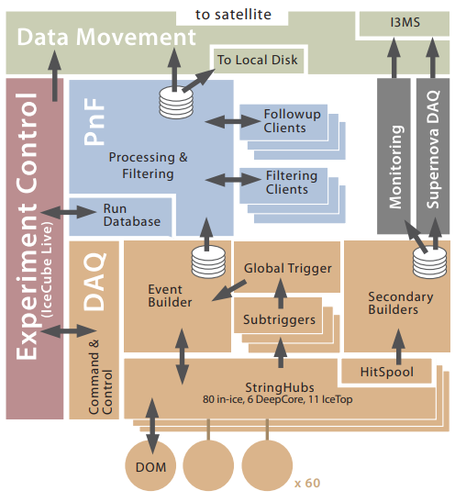

Figure The data flow of IceCube. StringHub can process non-physics data, which comes from monitoring and calibration, and sort raw physics data. Then HitSpool, a cache, queue all data, including those full waveform information, to serve for future requests from the Event Builder. Secondary Builders also possess functions for supernova events monitoring. It checks if the sum of data rate over a timescale is rising. If certain number condition is satisfied, further analysis will be implemented.

Filters set in IceCube serve for multiple purposes. SMT(simple multiplicity trigger) simply counts the number of HLCs in a certain time window.(say 8HLCs in 5 $μs$ for in-ice strings) Volume trigger requires 4 HLCs in 1 $μs$. String trigger requites 5 HLCs in 1.5 $μs$. Moreover, SLOP trigger(Slow Particle) are also designed for particles with velocity less than 0.01c, such as hypothetical magnetic monopoles. The time window in SLOP is much larger than normal trigger frame, so the photon multiplicity requirement and the time-space requirement are both stricter. At least six photons which satisfy a certain ‘velocity condition’ are in need to activate a SLOP trigger. FRT(the fixed-rate trigger) reads out 10ms of hit data from the full detection arrays at a fixed interval for monitoring purposes. The detailed results is listed below. String trigger is used to count the photon in the same string, aiming to extract atmospheric muons. Volume trigger uses a fixed cylinder around photon hit clusters, which allows those low energy events which may not pass SMT trigger.

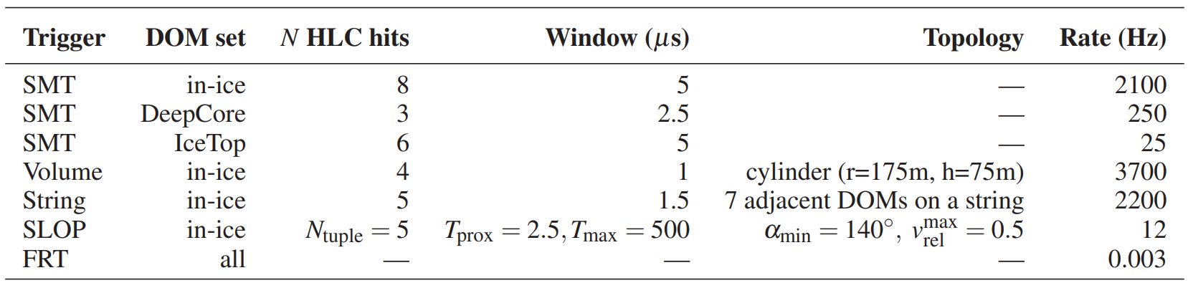

Figure The Trigger results summary from IceCube. SMT-single multiplicity trigger, SLOP-slow particle trigger, FRT- the fixed-rate trigger. ‘N HLC hits’ denotes number of hard local coincidence.

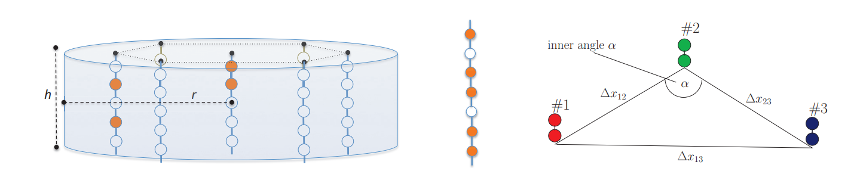

Figure Volume, String, SLOP trigger illustration. The marks corresponds to the ‘topology’ column in Figure 8. For SLOP, $v_{rel}^{max}=3*(v_{12}^{-1}-v_{23}^{-1}) / (v_{12}^{-1}+v_{23}^{-1}+v_{13}^{-1}), v_{ij}=∆x_{ij} / ∆t_{ij}$

1. KM3NeT

KM3NeT first applies mDOMs in neutrino telescope. 31 3-incd PMTs are equipped together. Dark count rates are superposed linearly. K-40 decay events surrounded the mDOM can contribute 6-8kHz raw hit rate per PMT, and double photon hits even triple photon hits also occurs steadily. This large noise hits force they adopt new read-out strategy. All waveforms are abandoned. Only the hits time and the time-over-threshold are recorded. The bandwidth is suppressed mostly in this phase.

The upper limit of bandwidth of one mDOM is 1Gb/s. Usually, 9-12Mb/s output bandwidth per mDOM is occupied, dominated by K-40. Bioluminescence can occasionally boost the bandwidth by a factor of 10.

The extraction of physics events is processed on shore in TriDas (the Trigger and Data Acquisition System, TriDas). Different filters are applied parallelly. In the first step, they use ‘L1 trigger’ to process raw data. They preliminarily define L1 trigger as two components, simple coincidence and charge excess. Within a time window of 5ns, one or more hits on different PMTs in the same mDOM are recorded, then it is a simple coincidence L1 trigger event. Photon hits with three photo-electrons charge is defined as a charge excess L1 trigger event. Latter on, they only use two photon hits in different PMTs in the same mDOM in 10 ns as L1 trigger. Charge excess concept is not in use in L1 trigger anymore.

The further process is named as ‘L2 trigger’. In this part, algorithms designed for several physics purposes work in parallel to select those more important photons hits clusters. L1 trigger already screens those isolated photon hits, which is mostly dark noise of PMT and K-40 hits. L2 trigger contains six parts.

1. T-Triggers: two L1 events happen on adjacent or next-to-adjacent mDOMs in 200ns. Or two L1 events occur in the same mDOM in 55ns.
2. Simple causality filter: in a large enough photon hits set, check if photons in cluster satisfy

$$\left|∆t\right|≤\left|∆\vec{x}\right|∙\frac{n}{c}$$

This probably aims to search cascade-like events.

1. Sky scan trigger: divide the whole sky ( $4π$ solid angle) in around one hundred region. For each direction, check whether the photons in a large photon hits set satisfy the following inequation mutually:

$$\left|(t_{i}-t_{j})c-(z_{i}-z_{j})\right|≤tanθ_{c}\sqrt{{(x_{i}-x_{j})}^{2}+{(y_{i}-y_{j})}^{2}}$$

${ θ}_{c}$ is the Cherenkov angle. ($x_{i}, y_{i}, z_{i}, t_{i}$) is the space-time coordinate of photon $i$. $Z$ axis is the direction pointing back to the sky region. The coordinate system is rotating when checking different directions. The calculation is done by assuming the coordinate system is aligning with the muon track direction. This trigger aims to select a direction if photons come from muon track events. Only when the checked direction is close to ‘the real direction’, the above equation can be satisfied. This trigger serves for the reconstruction of muon tracks in the next phase.

1. Tracking trigger: the specific calculation is the same with the sky scan trigger. The direction here is not from divisions of sky region. Instead, it comes from certain sources such as NGC 1068.
2. Vertex splitting trigger: Use inertia tensor of photon hits coordinates to check if photon hits are cascade-like or track-like. Calculate inertia tensor is simple and fast, which can save some time for detailed reconstruction. For example, if photon hits are very track-like, then cascade reconstruction will not be implemented for economizing computing space.
3. External trigger: alert message from other telescopes. For example, Gamma Ray Bursts were captured by some satellites.

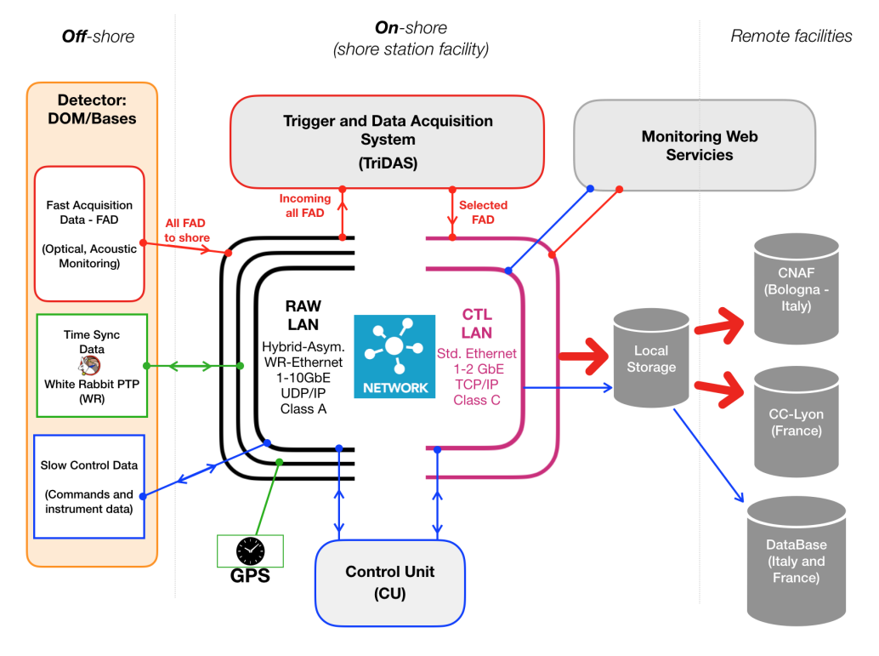

Figure Framework of data system for KM3NeT. From left to right, data flow from the front end to the final analysis are presented. Photon hit, acoustic data, positioning data and time synchronization system as well as instrument data are transmitted to shore station via RAW-LAN. TriDAS on shore will implement software trigger, including L1 and L2 trigger.

1. Baikal-GVD

In lake water, salt such as K-40 is barely contained, so the noise bandwidth is not super high. Relatively simple and fast methods are adopted when designing the data acquisition system. The trigger in the data acquisition system operates in two modes, L trigger and L&H trigger. The previous one demands coincidences of signals in the selected time interval, and the latter one asks for coincidence in any adjacent optical modules.

## 1.3 Purpose of Study

Even though noise contributes most in total bandwidth, and atmospheric muons contributes most in signal bandwidth, we should transmit all data to avoid the loss in physics information and be careful when reducing the background. Those relatively low-energy events(sub-TeV) may create only a few Cherenkov photon hits, which is not be significant enough to be distinguished from K-40. Even If the photons’ distribution in time and space are quite dense when the energy of neutrino events is high, those hDOMs far from the event vertex still capture few photon hits, which may cause misjudgment in extracting signals. The more stringent criterion we choose to suppress noise, the less pressure we face to transmit data, and the more physics loss we will face.

The purpose of this work is to explore the possible way to reduce the background as well as to make sure signals are not impaired. hDOMs in TRIDENT are equipped with most number of PMTs and SiPMs, than any other DOMs ever designed. Former neutrino telescopes are generally designed with the ‘all-data-reserved’ philosophy. As much as possible information is reserved when outputting the data to shore from DOMs. This strategy can be helpful to the simplicity and reliability of hardware design inside the DOM. And all information are reserved to the data station on shore, which avoids the potential loss of physics information. While, on the other side, this strategy is a waste of bandwidth. Retaining all noise in the cable is not necessary.

The next-generation neutrino telescope, Trident, may not be able to apply the same methods to transmit and digitize data, since the bandwidth is unprecedentedly high and the monitoring volume is incomparably large. New ways of trigger are in need to adapt to the current level of data transmission and computation. In one hDOMs, 55 photon sensors(31PMT+24SiPM) are applied. Without any raw data process, all digitized photon signals will occupy 2GB/s for one hDOM, which is 35TB/s for the large detection arrays. It is not a treatable data amount in this era. My work focuses on the hDOM internal trigger. The raw data will be suppressed and selected inside hDOM using our designed trigger algorithm. Interested physics signals, which only takes up very little bandwidth, should be retained as much as possible, while the noise should be abandoned. The detailed evaluation of our trigger algorithm in background suppression and physics loss will be presented in this paper.

# Chapter Two Trigger Strategy

## 2.1 Trigger Strategy Design

The trigger strategy design of Trident should not bear any physics loss, at the same time, suppress the bandwidth to satisfy the workload of data transmission. In one hDOM, 31 PMTs and 24 SiPMs are equipped. Large bandwidth from numerous photon sensors demand relative strict trigger criterion.

The framework of trigger constitutes two level. The first level is hDOM-internal trigger, abbreviated as L1 Trigger. It is the first stage to suppress the bandwidth by considering the number of PMT photon hits. The second one is referred as physics filter, generally called L2 Trigger. This part considers photon hits in adjacent or next-to-adjacent hDOMs. Physics signals will be extracted in this stage since photon hits are related mutually in space and time.

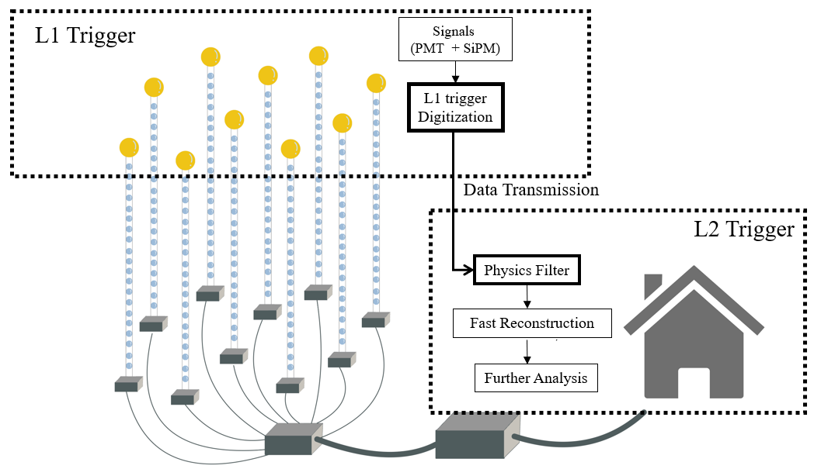

Figure Conceptual Framework of our data system. For the trigger system discussed in this paper, hDOM Internal Trigger (L1 Trigger) and Physics Filter (L2 Trigger) are two main components. Updated position information will be appended in data on shore for calculations in physics filter. The White Rabbit clock synchronization system are not involved above. From left to right, hDOM side, transmission site and on-shore site are listed in order.

Data from a local cluster of hDOMs, such as a hDOMs inside a cylinder or a sphere space will be extract for next-stage reconstruction. Some of the particle identifications can also be implemented in this phase. This part of trigger is finished at the on-shore station. Principally, in the junction boxes, part of these works can be conducted. While considering the engineering below the sea surface should be as simple and reliable as possible, we probably move the complexity on shore.

## 2.2 hDOM internal Trigger

L1 trigger decisions will be made by only PMT. Since the dark count rate of SiPM is in the order of $O({10}^{6})$, the trigger of SiPM is not very practical. Trigger in this level is implemented inside hDOMs. The waveform of L1-triggered events will be read out for particle identification and reconstruction.

The implementation of L1-trigger is summarized as follows:

1. If at least two different PMTs receive at least two photons in 10ns, the it is a L1-triggered event.
2. The waveform of total 1000ns will be read out. The first 300ns is before the L1-triggered event and the second 700ns is after-L1.
3. The 1000ns read-out time window is for the entire hDOM, including 31 PMTs and 24 SiPMs.

We expect that this part, the foundation of all later data processing, will suppress background, and make no influence on the physics events.

Other neutrino telescopes transmit all data to shore and then use a seires of triggers to process data. However, since the bandwidth of Trident is super high($O(TB/s)$,for all waveforms without trigger) and the workload of optical fiber in the sea cable is limited, we may design a FPGA inside each hDOM to process this L1 trigger. All the signals will be stored in analogue form in a buffer. When the coincidence condition computed by FPGA is satisfied, the triggered signals will be digitized by ADC and transmitted by cable. Otherwise, only the time and the charge of a hit will be obtained by TDC and much less information is transmitted. The physics loss in this phase are unretrievable, the criterion design must be very careful.

It is an obvious drawback that only two or more than two photons can form a L1 trigger. Single-photon condition can never satisfy the L1 trigger. This single photon from physics events can still carry some information that may be helpful for energy and direction reconstruction. Since the dark count and most K-40 decay generate single photon hit, it is quite difficult to distinguish a photon’s origin. A possible solution is that when a higher level trigger is satisfied, all data from the entire detection array or a large cluster of hDOMs are read-out. Moreover, TDC read-out method should also be considered, because the bandwidth from TDC is pretty small. L1 trigger itself cannot save single photon from physics signals.

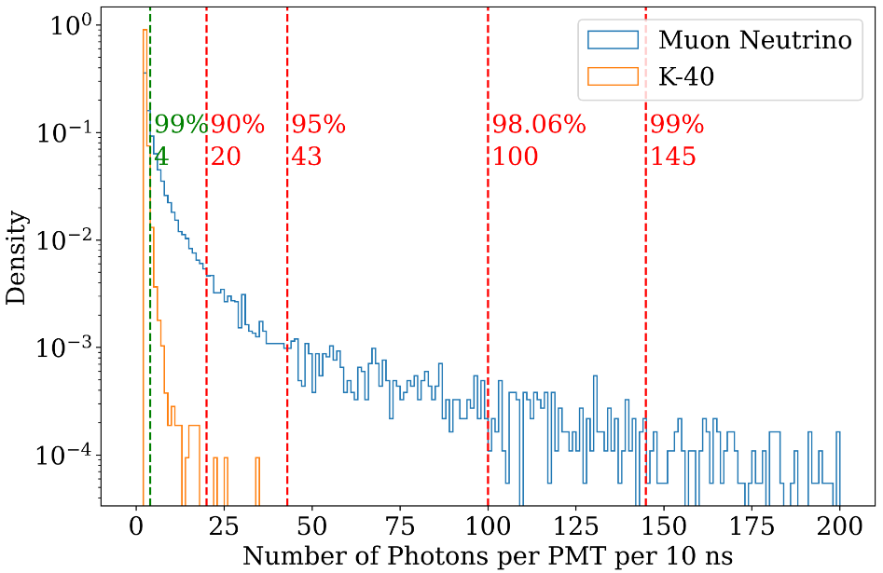

Figure The photon number distribution for a single PMT in 10 ns trigger time window. 10k muon neutrinos ranges from 1TeV to 10 PeV are simulated. The number of landed photon is much larger than the K-40 events. This characteristics of photon multiplicity is the foundation of our L1 trigger. K-40 events mostly generate less than 4 photon hit, while muon neutrino events can generate up to hundreds of photon hits.

The implementation of L1 Trigger relies on electronics design. The general framework of electronics is described below.

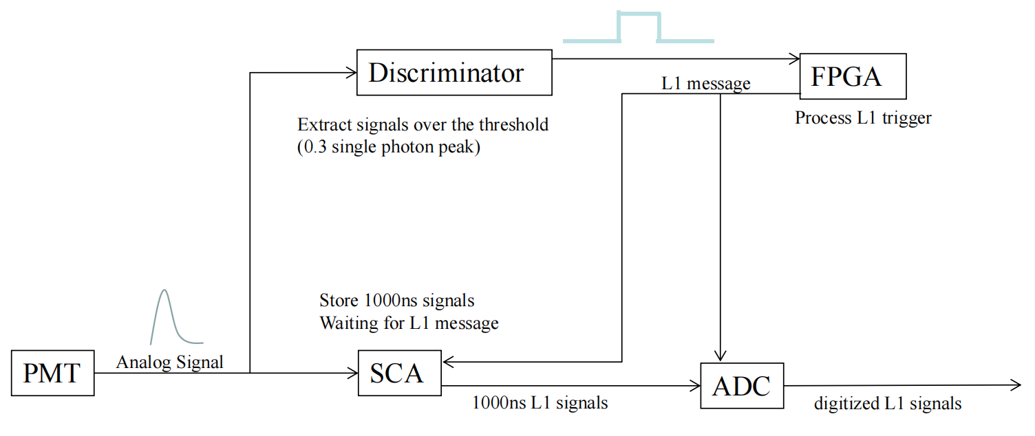

Figure The conceptual framework of electronics. It is worth mentioning that when ADC reads triggered data from SCA, time consuming is around three times of trigger time window, which is 1000 ns. So 3000ns dead time is expected for each L1 trigger, due to the read-out process of ADC.

## 2.3 Physics Filter

L2 Trigger is generally referred as physics filter. The main purpose of this part is to extract physics signals. This part is the subsequent procedure of L1 trigger and the guiding process before reconstruction. The function will be implemented in the computation infrastructure on the shore. The idea can be generally summarized as convex envelop search. For a series of photon hits distributed in 3D space and time(4 dimensional linear space), we should find a boundary to capsule all points without physics loss by considering the characteristic of physics signals, and the boundary should be as small as possible to reduce data amount.

For muon neutrino events, tau neutrino events, electron events, and atmospheric events, the signatures are widely different. Different reaction channels and different energies of the event corresponds to different size of boundary. Normally, for a 100TeV shower event, tens of hDOMs will be lightened. For 100 TeV track event, hundreds of photons will land in tens to hundreds of hDOMs. Time distribution for single PMT ranges from ten to one thousand nanoseconds. This feature requires that the physics filter should be loose and run in parallel to involve all situations. A strict ‘envelop’ involving all hits without redundancy is not practical without detailed reconstruction. Physics Filter phase does not involve complex computation. Simple and fast methods should be developed.

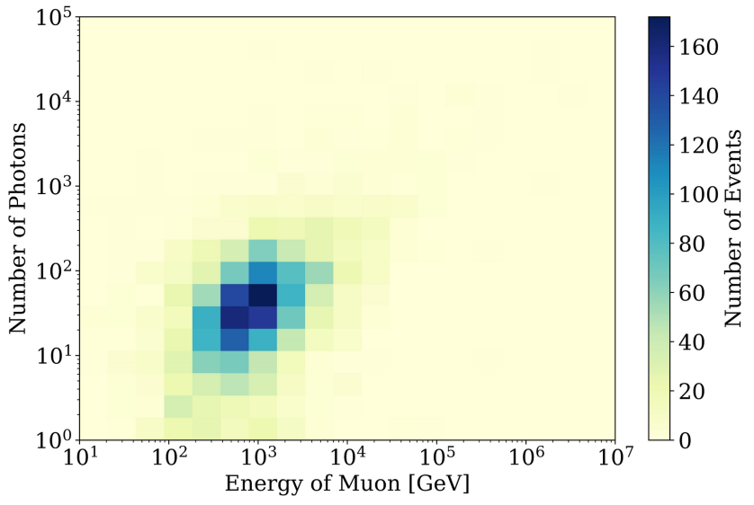

Figure Number of photons received from muon events from simulation. Quantum efficiency of photon sensors is considered. Large white area in the picture is due to a lack of statistics. If enough events are simulated, a linear blue band are expected since the number of photons should be proportional to the energy. But we can conclude that the photon number is distributed in very wide range for the events with the same energy. The wide distribution leads to relatively loose parallel physics filter.

We can first use a L2 trigger(level 2, a higher level than L1) to mark those corelated events, which is an indication of physics signals. The L2 trigger’s idea is basically the same as L1 trigger. It only considers the coincidence between 2 adjacent or next-to-adjacent hDOMs. If two L1-triggered hDOMs are adjacent or next-to-adjacent within around 1000ns, then these two hDOMs are L2-triggered. L2 triggered events is a strong indication of physics event instead of ambient noise.

Cylinder method and sphere method are proposed as preliminary solution for muon events and shower events. Once there are multiple L2 events or mixing of L1 and L2 events in the same cluster, these methods can be applied to the cluster of data for latter analysis.

1. cylinder method

The idea of the cylinder method is that photons from track-like events propagates within several times of absorption length of seawater. It is very safe to argue that almost 100 percent of direct photons are constraint in the length of 5 times of attenuation length (99.32% around 100m). So for track events, hDOMs in a large cylinder can involve all physics information. In this sense, data from only a proportion of detection arrays is processed. This helps to release the pressure of latter reconstruction computation. The direction of the cylinder can be selected from simply calculate the expected arrival time of photons. The complexity of the calculations is *O*(n). The calculated value should be close to the real occasions. The vertex of the muon track can simply use the center of mass of photon hits.

1. sphere method

For cascade-like events, electrons and gamma rays generate large optical photon shower within tens of meters. The photons from same events all obey the law of causality since they originate the same high-energy particle. When the number of L2 events occurs and their maximum distance is smaller than a certain value, data from hDOMs inside a sphere will be transmitted for reconstruction. The radius of sphere will be a redundancy length (for example, 100m) plus the maximum distance from the center of mass to the photon hits point.

In essence, these two methods rely on the characteristics that all physics events are local. A portion of hDOMs is enough to include all information. So not all hDOMs are used for reconstruction. The preliminary quantitative discussion is in the latter chapter.

# Chapter Three Performance of Trigger

The quantitative evaluation of hDOM internal trigger(L1 trigger) is presented in this chapter. We conduct a Geant4(a platform in C++ using Monte Carlo methods to describe passage of particles through matter) simulation to test its background suppression ability and the physics loss due to trigger. The bandwidth estimation is also conducted for the guidance of hardware design. The upper limit of bandwidth should be in the range of workload of out data system. The data amount in the future detection array should be computable and transmissible. Also, for dark noise, theoretical calculations is conducted.

## Simulation Framework

In our simulation framework, we construct one hDOM in the center of a sphere water world. When muon events are injected, the radius of the water world is 100m. When k-40 events are sampled, the radius of the water world is only 30m, since most coincidence events are in very short range limit. Cherenkov radiation can be generated in the process and captured by the PMTs inside the hDOM in the center. When the Cherenkov photons hit the PMT surface, its time, energy, and the PMT ID will be stored in a root file. A python analysis program will apply L1 trigger algorithm on the generated dataset. The purpose of the framework is to generate simulation signals and noise in one hDOM, and apply the trigger algorithm with adjustable parameters such as the time window, to finally evaluate the general performance of a certain set of parameters. The parameters of L1 trigger is named as the coincidence number $α$ and the time window $β$. If $α$ photons are captured in $β$ ns, then the hDOM is L1-triggered. And a 1000ns length digitized signal will be transmitted.

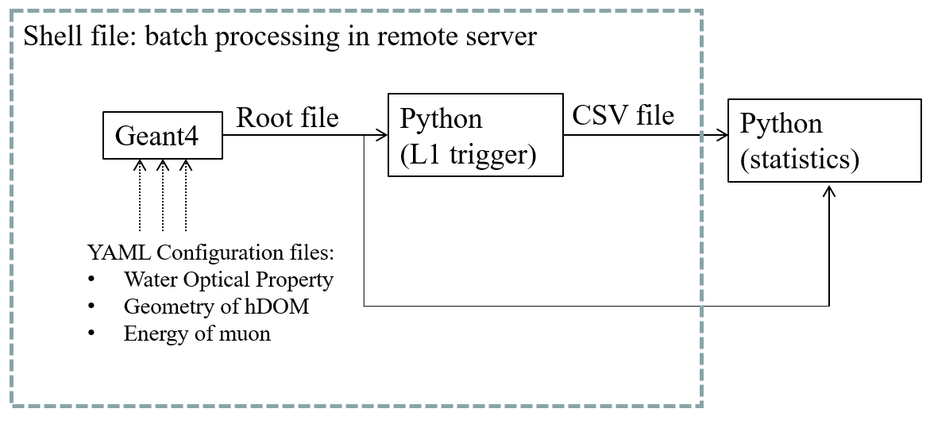

Figure Workflow of the simulation project. The geometry layout of PMTs and SiPMs in hDOM, muon energy and the water optical property are adjustable. Batch processing, which helps to significantly reduce the running time, replaces parallel computing to some extent.

The optical property of seawater including phase refractive index, Rayleigh scattering length, Mie scattering length, Mie scattering angle and absorption length is set for all wavelengths. The group refractive index can be automatically processed by Geant4 build-in function.

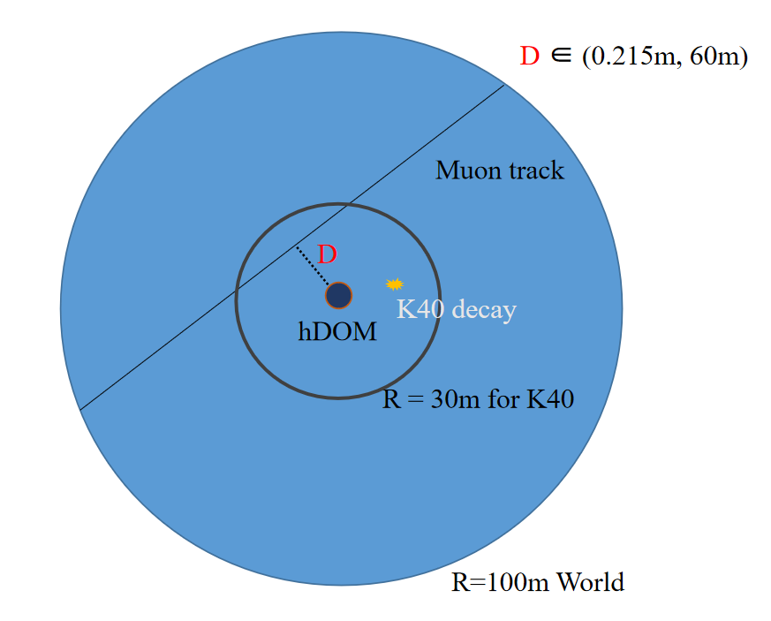

Figure Geometry of Geant4 simulation project. The geometry of hDOM is set basically the same with the situation in Figure 3. The outer glass shell, optical gel, and part-sphere shaped PMTs are established.

For k-40 decay events, there are two branches. 10.698% events generate 1.459 MeV mono-energy gamma rays, and 89.302% events generate electrons. The energy of electrons ranges from 0.1MeV to 1MeV. Other secondary particles such as neutrinos from this beta decay are not observable. The source of optical photons in essence is the around ten percent gamma rays and ninety percent electrons. So we inject electrons and gammas corresponding to the branch ratio and energy spectrum to simulate the decay events. As for the position of the decay events, uniform distribution in 3D space is assumed. The seawater is homogeneous in terms of radioactivity.

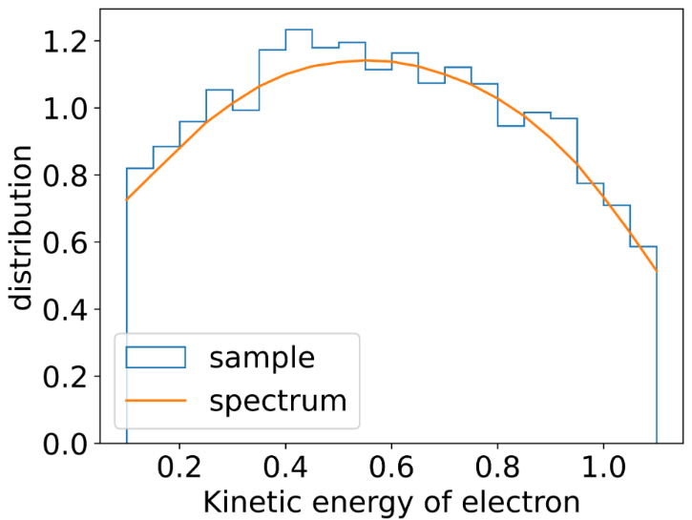

Figure kinetic energy spectrum of electrons from K-40. The yellow line is from theoretical results. The histogram is sampling results from the Geant4 simulation.

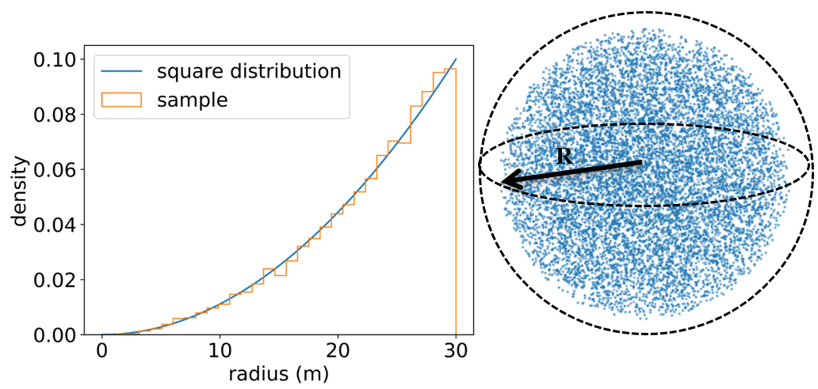

Figure The position sampling of K-40 decay. Left panel: theoretical results of square distribution and the sampling result. The radius of uniform positioning in sphere should obey square distribution. Right panel: 3D scatter visualization of the sampling result.

For muon track, the distance from the hDOM to the track and the energy can be manually adjusted in each simulation. The direction of muons are uniformly distributed. We focus on the distance at around 30m and the energy is around hundreds of GeV to several TeV. Since this part is the subtlest region. When the energy is higher, or the distance is closer, the specific trigger algorithm does not matter anymore, since the event is bright enough.

### 3.1.1 Analysis method

To process the root file from Geant4, a python script is created. Part of photons are abandoned according to the quantum efficiency property of PMT. Then the photons are sorted by the arrival time in ascending order.

Then, in order to check if there is $α$ photons in $β$ ns, the time difference of the previous photon and the latter photon is calculated. The complexity of this step is *O*(n). Secondly, we check if the sum of $α-1$ intervals is smaller than $β$ ns. If it is smaller, then a L1 trigger event is set. All photons within 100ns time window will be labeled as L1 photons. It is very fast if numpy or pandas package in python is included in the second step, since they all run in parallel.

The PMT ID of L1 photons is sometimes also put in use. Since we may pick up the photons landed in adjacent PMTs.

All L1 photons will be selected and stored in another csv file for latter analysis. The rate of K-40 L1-trigger event is calculated by the number of L1 photons divided by $α$. As for the success ratio of muon events, we check if a muon can generate L1 triggered photons. If there is, then the muon is labeled as successfully L1 triggered. The success ratio of muon events is calculated by the L1 triggered muon divided by the total injected muon.

The python script can process different $α$ and $β$ in parallel. The most time-consuming process in the analysis generally is read-out and write-in procedure. The total run time in the server is controlled down to several seconds for one single $(α,β)$ set. We scanned the phase space of L1 trigger $(α,β)$ set.

## Background Reduction

### 3.2.1Dark Noise

This part is conducted by theoretical calculation. Dark noise, or dark count, is the inherent thermal property of photon sensors. We assume the frequency of the dark noise is $f$. This number is 300Hz/PMT or 300kHz/9mm^2 SiPM at around 2 degree in Celsius(deep sea temperature from experiment). And the time of dark noise photon is sampled in uniform distribution. The probability to expect $α$ photons in $β$ ns is described by the integral of gamma distribution. L1 false trigger rate R by dark noise is given below.

$$R = f\int_{0}^{β}{Γ(α-1,\frac{1e9}{f})(t)dt}$$

The $\frac{1e9}{f}$ parameter is the expected time interval between two dark photon hits. The parametrized $Γ$ function is defined as:

$$Γ(a,b)(x)=\frac{b^{a}x^{a-1}e^{-bx}}{\int_{0}^{∞}{t^{a-1}e^{-t}dt}}$$

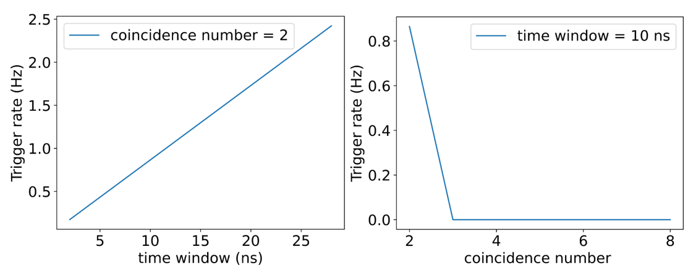

Figure The left panel: the trigger rate vs time window $β$

The right panel: the trigger rate vs coincidence number $α$. At most, when $(α,β)=(2,30)$, the trigger rate is 2.4Hz, three orders of magnitude smaller compared with K-40. For those coincidence photon number is larger than 2, the trigger rate is negligible. When $(α,β)=(3,30)$, the trigger rate is 0.00005Hz.

### 3.2.2 K-40

The K-40 decay events are the most dominant noise source for Trident. The activity of K-40 is around 10Bq/L (10.89Bq/L as simulation input in this chapter), and seawater within tens of meters can contribute photon hits. The Cherenkov threshold for electron in seawater is around 0.3MeV. Most electrons from K-40 decay can generate numerous optical photons by Cherenkov radiation. This leads to the result that the rate of noise hit from K-40 can reach up to around 60k Hz per 31PMTs in one hDOM ($2.02±0.09kHz per PMT$), according to our simulation result.

After L1 Trigger processing, K-40 event rate is reduced by around two orders of magnitude. The L1 event rate per hDOM (31PMT) induced by K-40 is studied. We adjust two parameters of L1 trigger, coincidence photon number $α$ and time window $β$. An L1 event is defined as at least $α$ photons occur in $β$ ns at different PMTs in one hDOM.

Figure K-40 Trigger Rate in one hDOM. The left panel is the K-40 trigger rate changing with along with the time window $β$. The right panel is the K-40 trigger rate decreases as the coincidence photon number $α$ increasing.

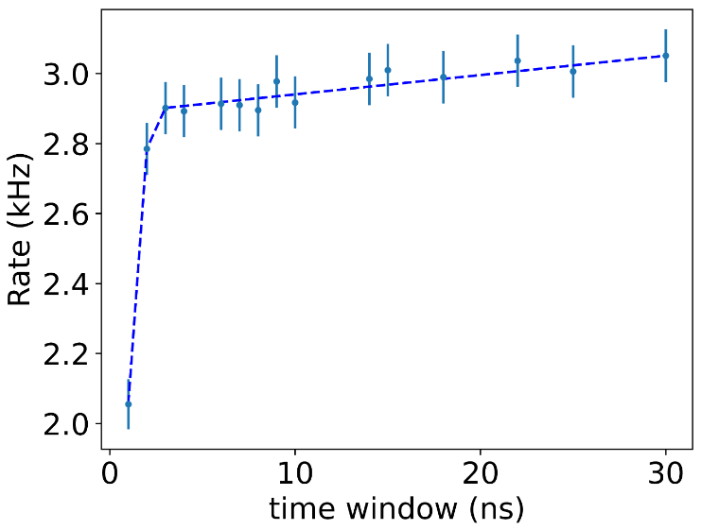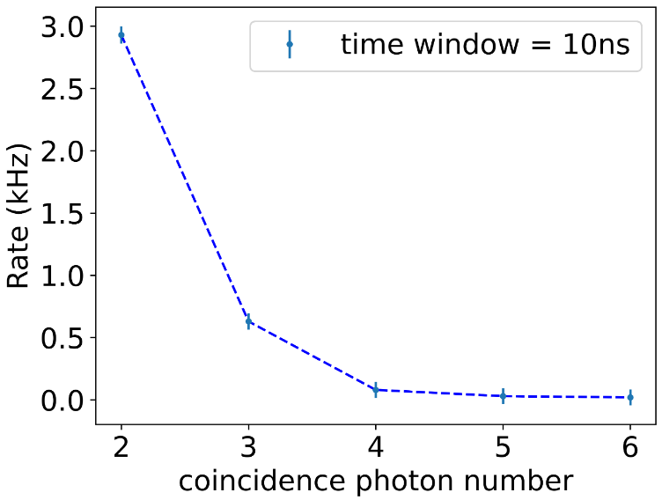

As the time window increases, those photons which possess larger time interval can pass L1 trigger. So The trigger rate is increasing. These coincidence photons mostly come from the same decay events, so that the expected time interval of coincidence photon pairs is quite small in fact. After the time window becomes larger than 10 ns, all coincidence photons are almost involved and the trigger rate become gradually saturated. Finally, as the time window approaches 30 ns, the trigger rate seems to converge to around 3kHz. The message we can take from the trend is that after a certain value, such as 10 ns, the time window is not important for L1 trigger. The algorithm is not sensitive to this parameter any more.

The coincidence photon number is another parameter in the L1 trigger algorithm. It describes the threshold in the photon multiplicity. The K-40 L1 trigger rate decreases sharply as the number increases. It is intuitive to think that if the probability that one K-40 decay generates a photon that can land in the hDOM is $p$, then the two-photon case corresponds to $p^{2}$ and the three-photon case is $p^{3}$. The probability $p$ here describes mainly the absorption effect of seawater. And the number uncertainty of Cherenkov photon emission can also influence $p$ slightly. Consider 2 photons in 10ns and 3 photons in 10ns, the former one is 2.9kHz while the later one is 0.6kHz. Increasing the photon number threshold is quite effective in L1 trigger to reduce the K-40 decay events.

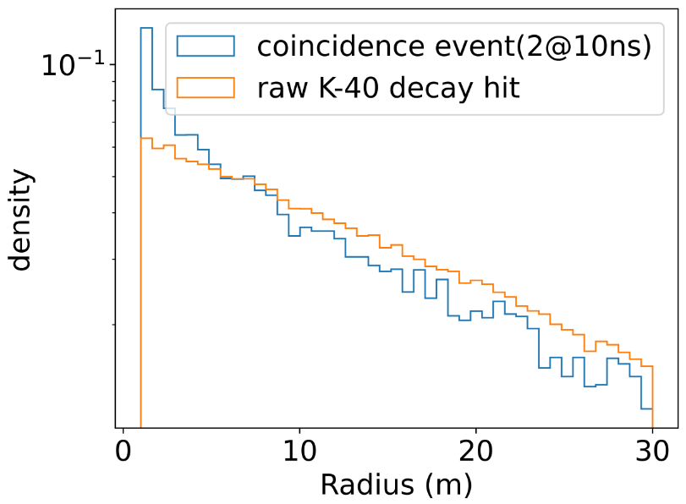

Figure The radius that K-40 events occurs. The x-axis denotes the distance between K-40 events and the hDOM. We can notice that double coincidence events are more likely to happen near the hDOM, which leads to the fact that double coincidence is rarer than single hits.

As the radius increases, the volume of water space is increases ($dv=4πr^{2}dr$). Meanwhile, the solid angle of hDOM to the K-40 events is decreasing correspondingly ($dΩ=\frac{dA}{4πr^{2}}$). The radius factor is canceled mutually. So the trend that coincidence events are closer to hDOM in Figure 22 comes from the absorption of seawater. If the K-40 decay event is far from hDOM, then emitted photons will be largely absorbed. This absorption effect reduces the photon multiplicity and provides the guidance of L1 trigger design.

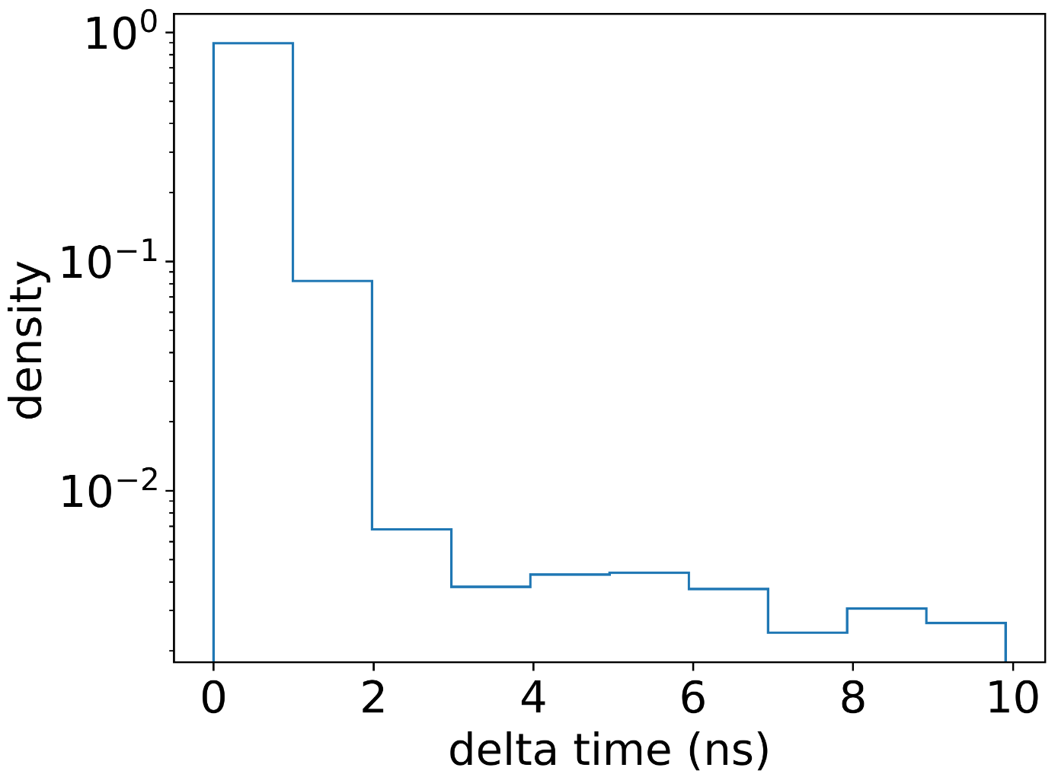

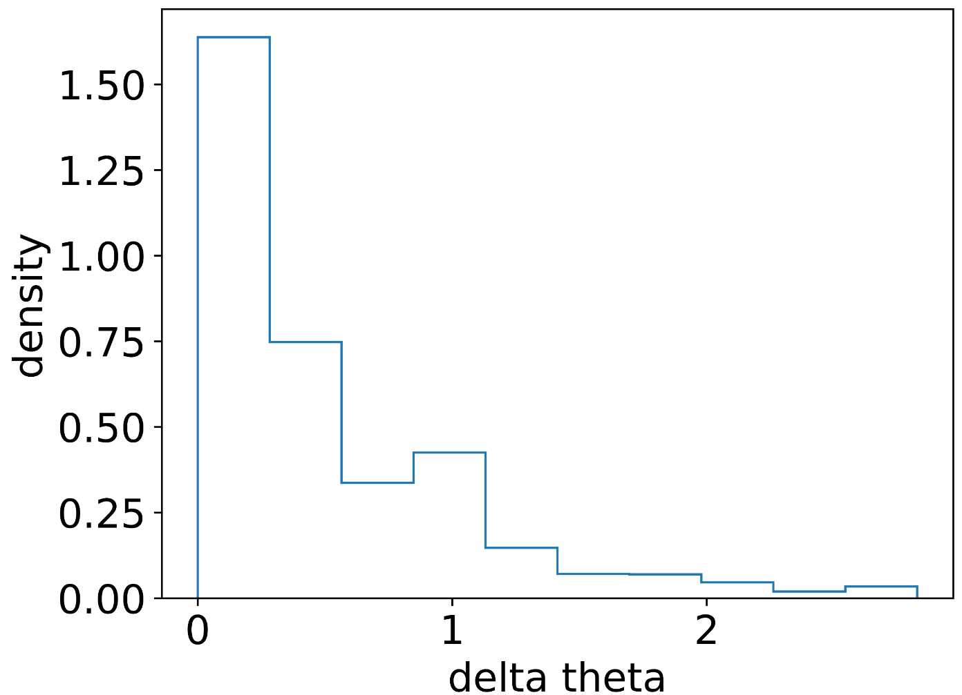

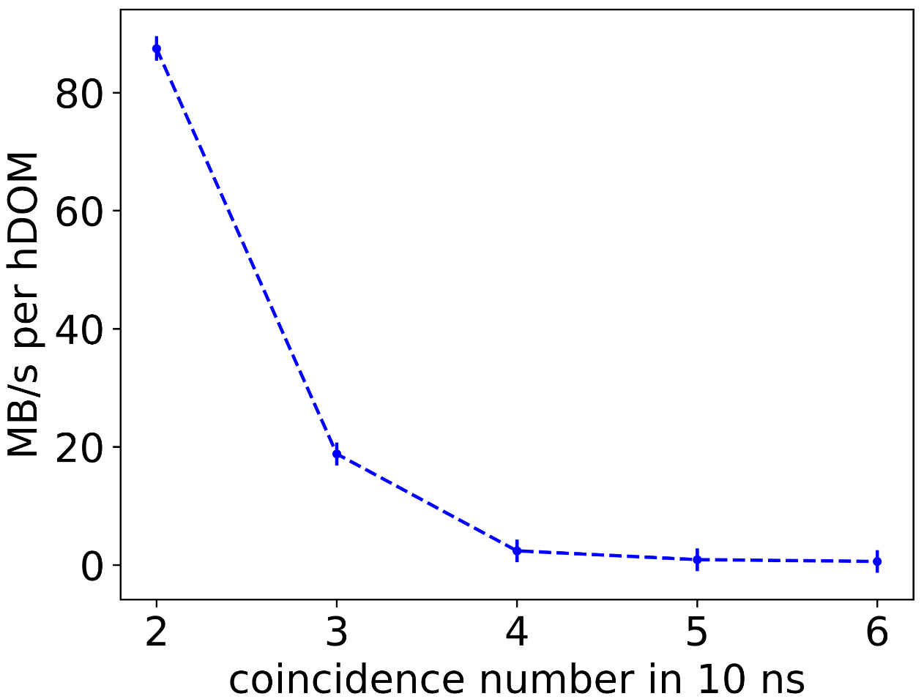

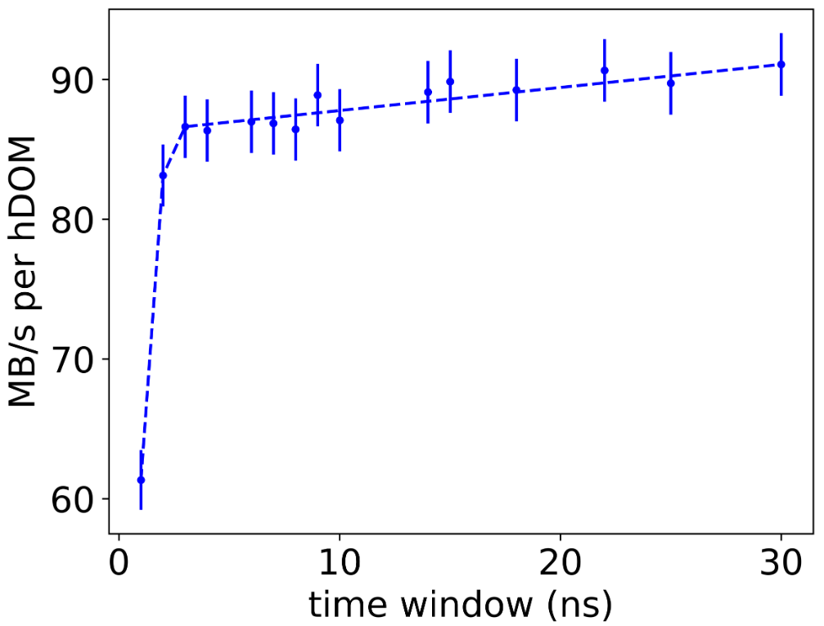

## Signal Event Evaluation

Mention Fit 16.1m

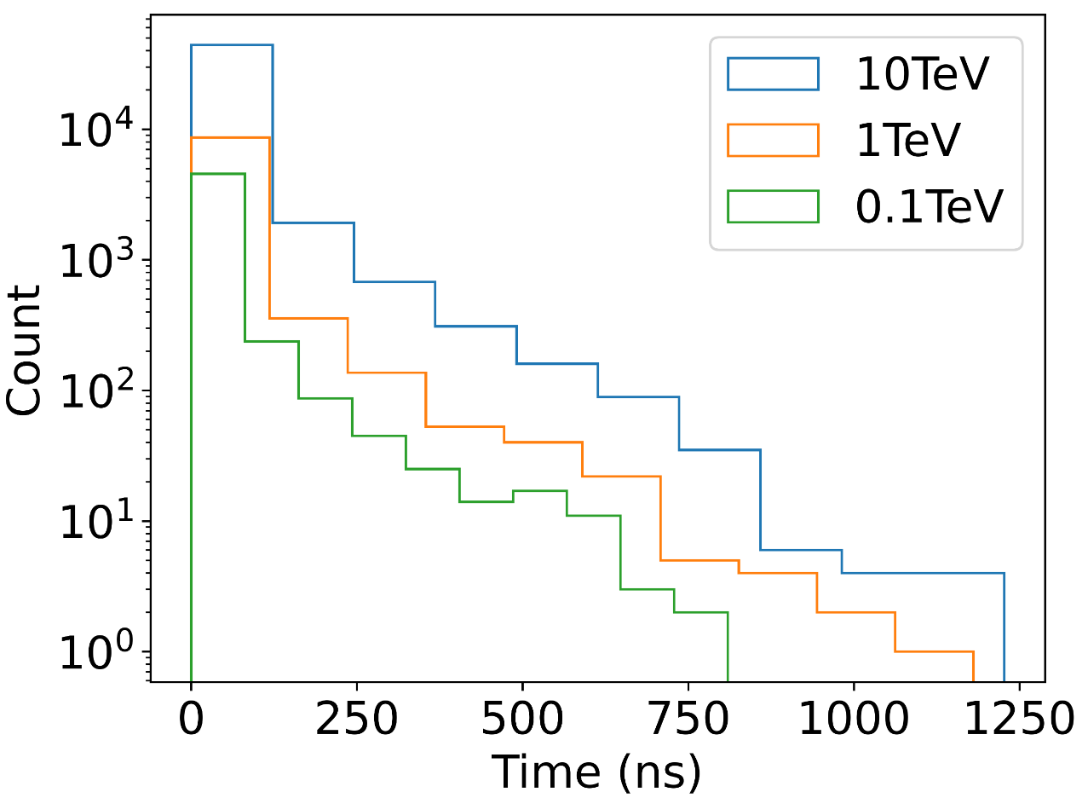

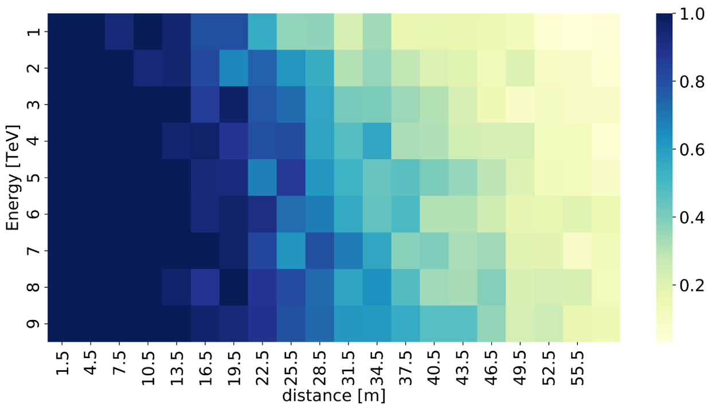

Arrive /sim

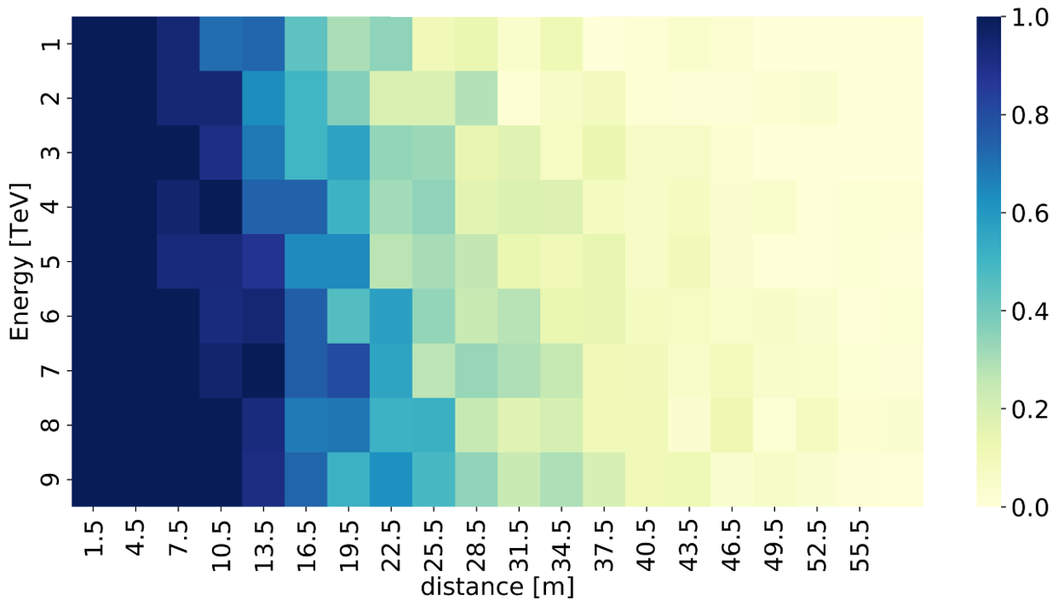

2@10

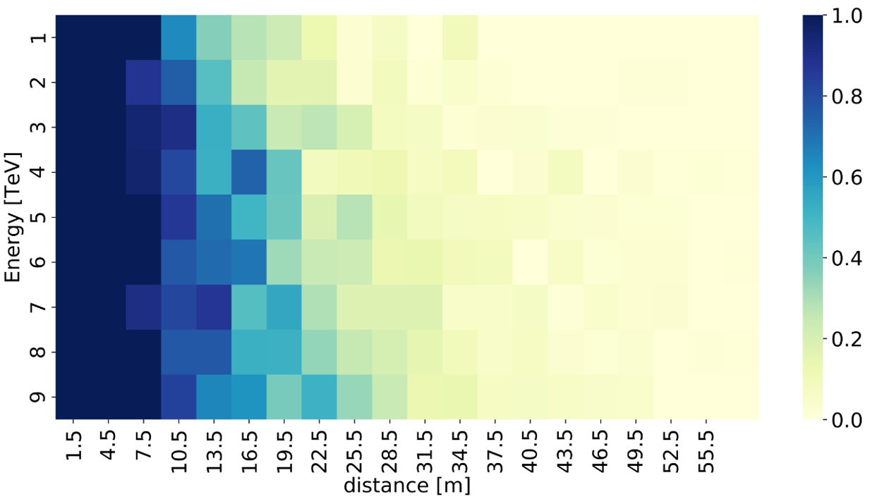

3@10

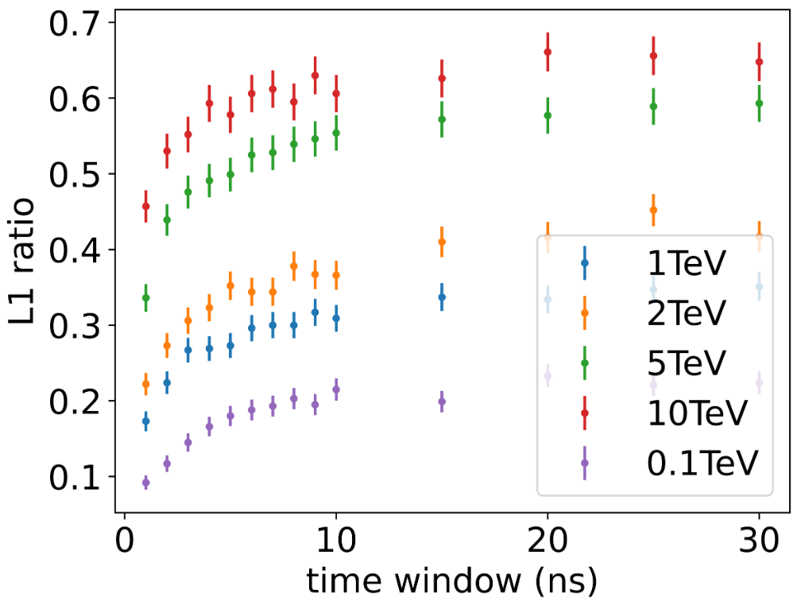

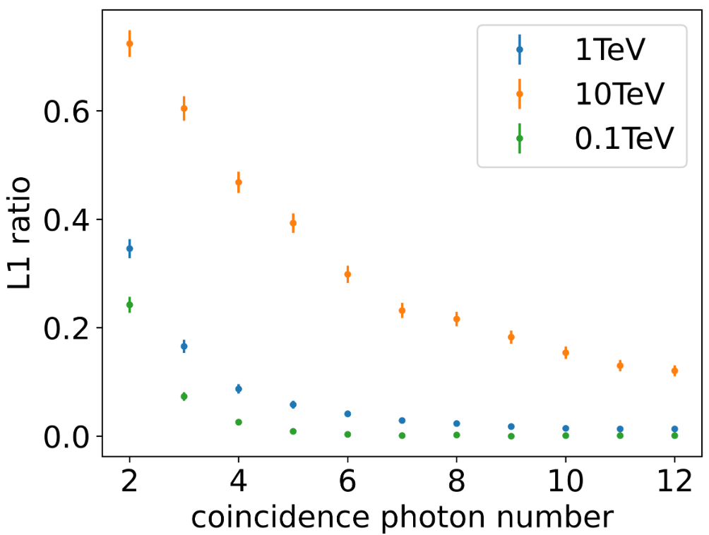



ILLUSTRATION 3-1 XXX

 （3-1）

## 3.3 Summary

……

# Chapter Four Future Improvements and Outlook

## Physics Filter Optimization

……

### 4.1.1 Electron Event

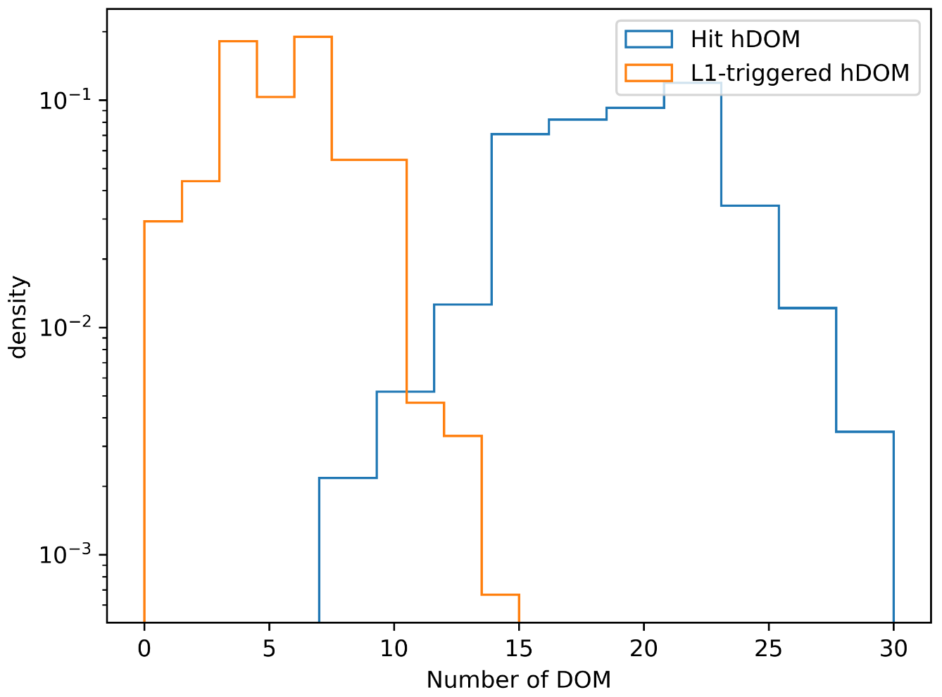

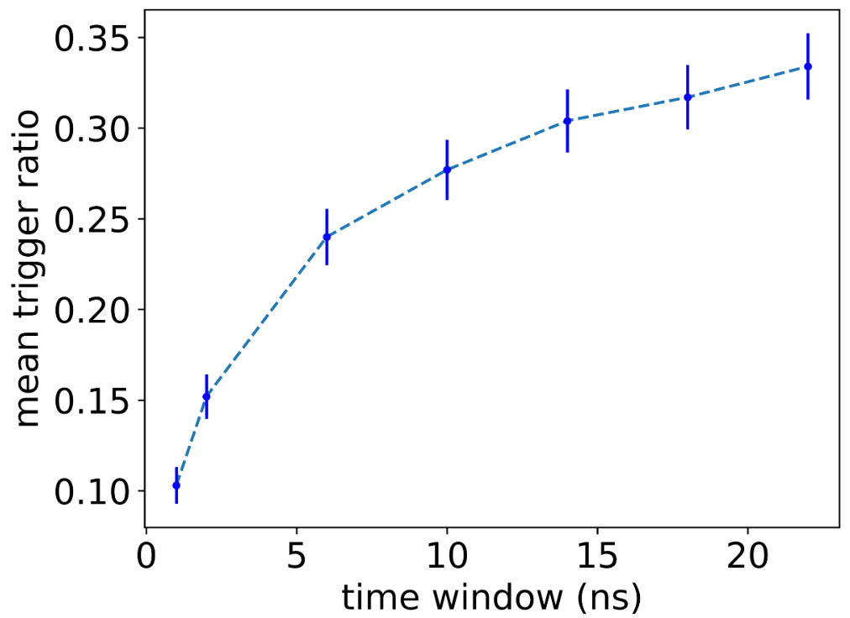

## 4.2 Data Acquisition System

……

# References

[1] 杨瑞林, 李力军. 新型低合金高强韧性耐磨钢的研究[J]. 钢铁, 1999(7): 41-45.

[2] 于潇, 刘义, 柴跃廷, 等. 互联网药品可信交易环境中主体资质审核备案模式[J]. 清华大学学报(自然科学版), 2012, 52(11): 1518-1523.

[3] Schinstock D E, Cuttino J F, Real time kinematic solutions of a non-contacting, three dimensional metrology frame[J]. Precision Engineering, 2000, 24(1): 70-76.

[4] 温诗铸. 摩擦学原理[M]. 北京: 清华大学出版社, 1990: 296-300.

[5] 蒋有绪, 郭泉水, 马娟, 等. 中国森林群落分类及其群落学特征[M]. 北京: 科学出版社, 1998: 5-17.

[6] 贾名字. 工程硕士论文撰写规范[D]. 上海: 上海交通大学, 2000: 177-178..

[7] 张凯军. 轨道火车及高速轨道火车紧急安全制动辅助装置: 201220158825.2[P]. 2012-04-05.

[8] 全国信息与文献标准化技术委员会. 文献著录: 第4部分 非书资料: GB/T 3792.4-2009[S]. 北京: 中国标准出版社, 2010: 3.

（参考文献格式请参考GB/T 7714-2015《信息与文献 参考文献著录规则》）

# Symbols and Marks Appendix 1

# Research Projects and Publications during Undergraduate Period

[1] ……

# Acknowledgements

……